
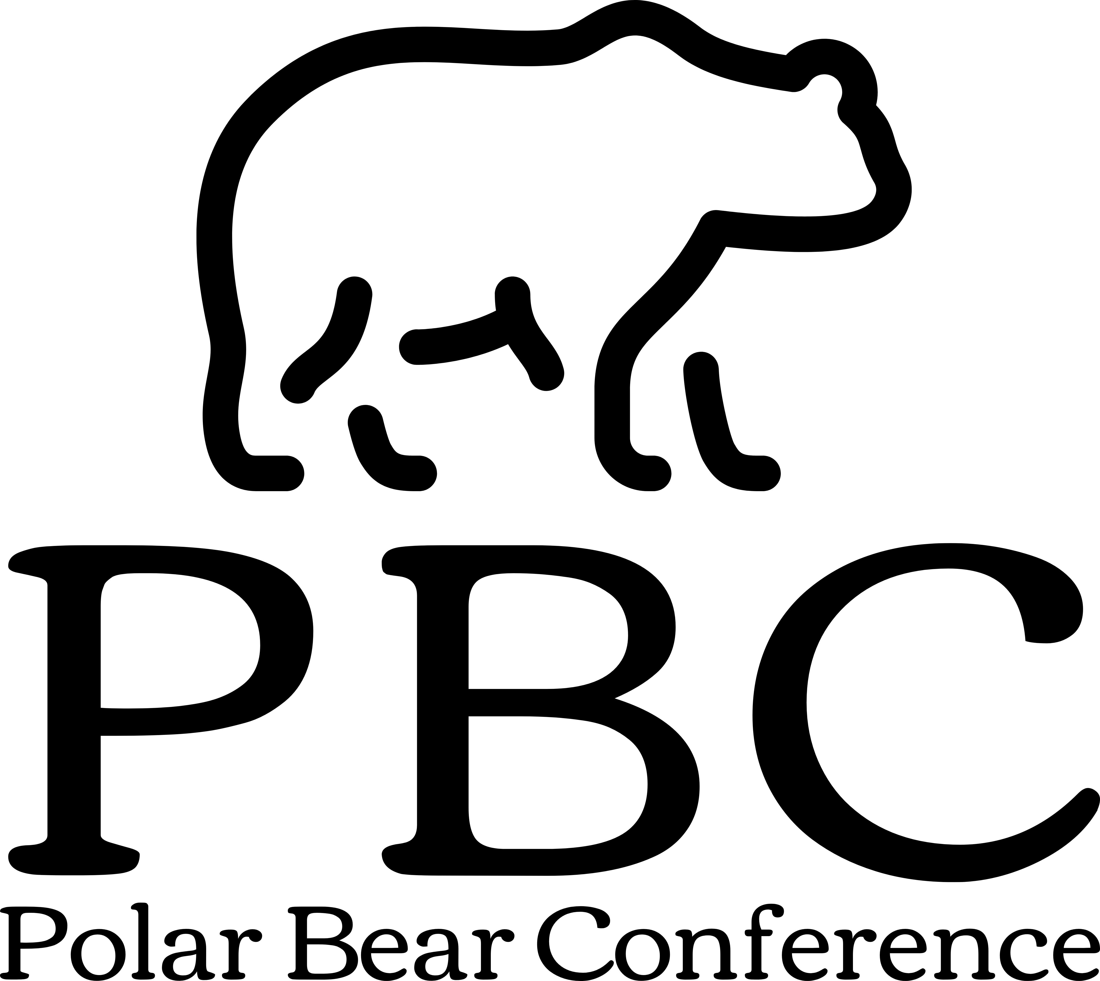
Cultural Competency &
Diversity
May 19, 2023

Bowdoin College: Moulton Union

8:00-8:10am Cultural Competency & Diversity: Introduction
Benje M Douglas, Bowdoin College
Senior Vice President for Inclusion & Diversity

8:15-9:15am Multicultural Awareness: How to build teams and environments where everyone belongs
Eduardo Pazos Palma, Bowdoin College
Director of Multicultural Student Life

9:30-10:30am Affirming: All Genders All Sexualities Workshop
Kate Stern, Bowdoin College
Director of the Sexuality, Women & Gender Center

10:45- 11:45am Fostering an Inclusive Culture in Healthcare
Jennifer Sturtevant, MBA, LAT, ATC Tufts Medicine
MelroseWakefield Hospital
Chair NATA LGBTQ+ Advisory Committee

11:45-12:00pm Closing Remarks

Schedule of Events

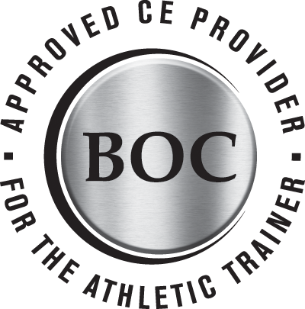
Information: 207-725-3018 (www.polarbearconference.org)

Registration Fee: $40.00 [Refund Policy: There will be no refund for cancellations. Registration refund will only be provided in the event of program cancellation. If participants register and do not attend the session, they are still responsible for full payment.]

Checks Payable: Bowdoin College Athletic Training,
9000 College Station Brunswick, ME 04011

The Polar Bear Conference is recognized by the Board of Certification Inc. to offer CEUs for Certified Athletic Trainers. The Polar Bear Conference will offer a maximum of 3.0 CEUs in Category A. AT’s should claim only those hours actually spent in the educational program.
Tuition

Registration

Provider #P3541

Return to Bowdoin Athletic Training:

Name_______________ k____ Name_______________________________________________ Work____________________________

Title_________________________________________ Phone____________________________

Address_______________________________________________________________________________

________________________________________________________________________________
(City) (State) (Zip Code)

Email _________________________________________ AT BOC. #________________________
Tuition

$60.00 per person x___ number attending = $_________
Please make checks payable to: Bowdoin College Athletic Training Department.

*48-hour cancellation policy for full refund of tuition*

Presentation Objectives

Polar Bear Conference: Cultural Competence & Diversity

Multicultural Awareness:
How to build teams and environments where everyone belongs
Knowledge
1. Attendees will work to identify the ways in which they first saw race in their own lives.
2. Attendees will identify the level of diversity present in their own social contexts.
Analysis
3. Attendees will break down the prevalence of racialized identity in Hassan’s story and how it
Benefitted him and disadvantaged him.
4. Attendees will analyze their fields and practices to identify ways in which race and culture
Play a role in their work.
Synthesis
5. Attendees will develop practices to become more self-aware and proficient in working with
Racially diverse students.
6. Attendees will come up with their own “why” statements. Why does multicultural
competence matter? How does it contribute to their own mission and professional ethic?
Evaluation
7. Attendees will assess their current work practices and environments and compare them to
The previously developed practices for working with racially diverse students.
Apply
8. Attendees will formulate their own Principles to incorporate Multicultural and Antiracist
Practices to their work and challenge the ones that do not support the goals of being more
Inclusive and aware of racial and cultural backgrounds.

Affirming: All Genders All Sexualities Workshop
Knowledge
1. Attendees will be able to understand the meaning and differences between gender and sexuality.
Analysis
2. Attendees will be able to think through where LGBTIQA youth might not feel safe and affirmed in their environments.
Synthesis
3. Attendees will have the space to talk with others and think through what safe and affirming environment could look like for LGBTIQA youth.
Evaluation
4. Attendees will be able to think through what changes might be needed to create a more affirming environment for LGBTIQA youth.
Apply
5. Attendees will have the space to create action steps in creating a safe and affirming space for LGBTIQA youth.

Fostering an Inclusive Culture in Healthcare
Knowledge
1. Attendees will be able to define commonly used terms that create cultural awareness with colleagues and patients.
Analysis
2. Attendees will be able to differentiate between explicit and implicit bias as well as identify and challenge internal discriminatory beliefs.
Synthesis
3. Attendees will be able to develop strategies on how to be an inclusive leader and ally within the healthcare profession.
Evaluation
4. Attendees will be able to identify policies, procedures and guidelines within your organization that may not be inclusive or equitable such a patient code of conduct or non-discrimination policies and make recommendations to update appropriately.
Apply
5. Attendees will be able to work respectfully and effectively with diverse populations and colleagues using the necessary skills and knowledge by interacting, discussing, and enhancing communications with individuals of unique backgrounds. Attendees will know how to engage in critical and conscious thinking when making decisions.

